# Problem Statement: -

As the world is moving ahead towards the modernization with the help of technologies everyone is busy with their daily routine. Due to which it is difficult to visit different websites and compare them. This problem will be understood better with the help of an example.

Suppose there is a student who lives in Dehradun has to book an appointment with the doctor at Aims Delhi so first he books the appointment and then he has to wait for the appointment to be confirmed by the doctor. After that he proceeds with the booking of hotels, decides his travel mode, and books the cab and many other things. So he spends most of his time in the after process of appointment and has to do a lot of comparison to get a best deal.

* Customer Collaboration:-

The third principle says Customer collaboration over contract negotiation. As nowadays if someone searches for sth on the web then in the results the first those things come up with Ads or are affected with virus and many other things which can waste the time of customer with the accurate results. So using Ai and RPA is a website booster site views and business growth. It is increasing the visibility of website or web page to users of a web search engine. It shows natural results and excludes direct traffic. So as are statement says that customer collaboration is a customer who is purchasing your solution so as in the market today it is important to understand the customer needs and satisfy them so are project also deals with this thing as our priority is customer satisfaction first. This is how we can relate this statement with our plan.

# ER-Diagram

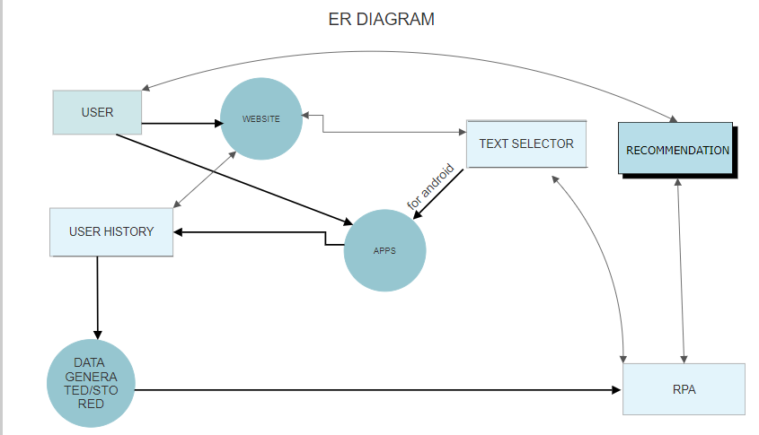

### RPA: -

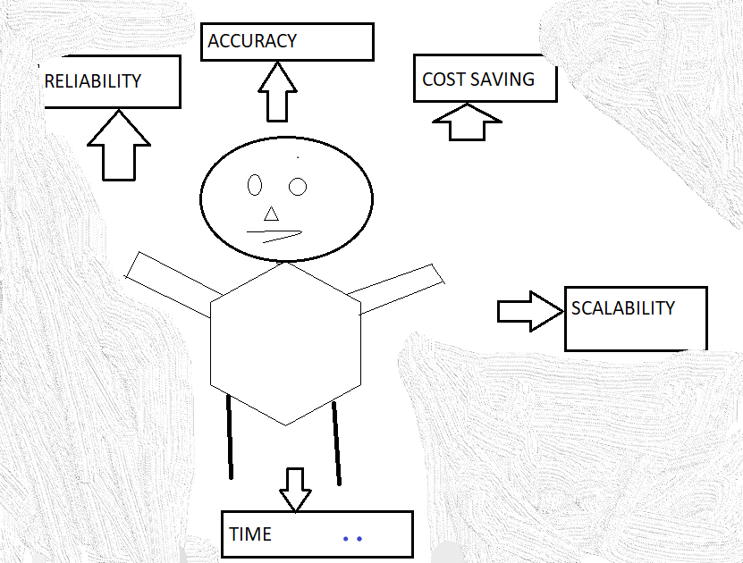

# Data Flow Diagram: -

# C:\Users\Admin\Desktop\Presentation_H4\AGILEdataf.PNG